Rocky Says

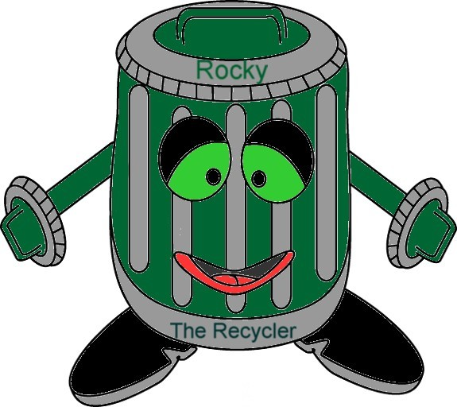

Northern Peninsula Regional
Service Board
P.O. Box 130, St. Anthony, NL, A0K 4S0
Tel: (709) 454-3110, Fax (709) 454-3818
nprsb@nf.aibn.com
www.norpenservices.ca
___________________________________________________

September 19, 2014

Waste Collection Policy

Communities: Main Brook, Croque, St.Julien’s, Conche, Roddickton, Bide Arm and Englee

Northern Peninsula Regional Service Board (NorPen) would like to thank the residents and businesses for their cooperation in regards to waste collection.

NorPen’s policy on waste collection is curbside (maximum of 10 ft. from end of pavement).

This policy was not being correctly implemented which has led to health and safety issues for employees and the general public. Employee and public safety has to be top priority while providing this service. Therefore, we are asking residents to respect and support this policy to ensure the health and safety of all involved.

We understand that not all residents can place their waste bins on or near the curb. If this should be the case waste will have to be removed from the bin and placed on the curb by 8:00 a.m. on collection day.

Effective September 29/14 any bins that are not located within specified range will have waste tagged. Residents will then be granted 2 weeks to move their bin or waste for the next collection day.

Please see our website (www.norpenservices.ca) for further information on waste collection and other services.

NorPen apologizes for any inconvenience this may cause.

